Zeynep Toraman

Dreaming of Emperors:
The Occulted Geometry of a Sixteenth-Century Ottoman Manuscript and Its Reemergence in Neural Network Generated Images

This essay draws a comparison between two visual cultures through case studies of the illustrations of Kıyafetü’l-İnsaniyye fî Şemâili’l-Osmâniyye (1579), a sixteenth-century Ottoman manuscript attributed to Seyyid Lokman and Nakkaş Osman, and Google’s computer-vision program DeepDream. I argue that both Nakkaş Osman’s and the DeepDream neural network’s respective approaches to visualization are based on a similar way of seeing: they invite an introspective gaze from their beholder in which internal and external vision mutually reinforce one another. I extend my consideration of the role of introspective gaze invited by the ornamental layer in Nakkaş Osman’s paintings to the viewing experience of images generated through DeepDream’s neural-network software. Through their shared principle of layered reconstruction of the visual domain and their use of low-level iconographic specificity, both image cultures convolve the internal and the external senses to invite an intimate, close-up way of seeing, further complicating the binary opposition between figure and ornament.
Many active algorithms of computer vision are based on the principle of convolution, which according to the Oxford English Dictionary, refers in mathematics to “a function derived from two given functions by integration which expresses how the shape of one is modified by the other,” or “a method of determination of the sum of two random variables by integration or summation,” but it can also have the more colloquial meaning of “a coil or twist.” Google’s DeepDream software, developed by Alexander Mordvintsev, was first introduced in the Google blog “Inceptionism: Going Deeper into Neural Networks.” DeepDream’s artificial neural network, which typically consists of 10-30 stacked layers of artificial neurons, is fed millions of training examples and with the gradual adjustment of network parameters. The software was originally developed to help software engineers to “understand how neural networks work and what each layer has learned,” as what exactly is processed in each layer is one of the major challenges of neural networks. DeepDream reverses the deep convolutional neural network based image classification pipeline, and allows the user to “choose which layers in the network to enhance, how many iterations to apply and how far to zoom in.” Mordvintsev et al. assert that “lower layers tend to produce strokes or simple ornament-like patterns, because those layers are sensitive to basic features such as edges and their orientations,” while the involvement of higher network layers leads to more figural forms to emerge. The software, although primarily developed for a niche audience, gained a vast popularity among programmers upon its initial release, and also became a widely used tool for artists due to its versatile ability to augment and transform existing images.
I turn to the category of ornament within the historical study of Islamic art, with an emphasis on its definition as a site for inquiry with a perennial capacity to ignite the artistic imagination and give aesthetic pleasure, as a useful tool when contemplating the powers of DeepDream’s seemingly arbitrary generative rules as a medium of artistic expression. Mordvintsev et al.’s reference to ornamental-like patterns in his description the visual world of DeepDream inspired my investigation of the cognitive potential of the ornament. The relationship between ornament and cosmos can be observed in both the computer-generated images of new media art and Islamic art, as both propose ways to reach infinity from the perspective a single point. Thus, I trace the metaphor of “a coil or twist” in convolution and highlight the expressive quality of the abstract line, privileging movement over figure, observed in the visual domains of computer-produced objects and Islamic art. Both of these produce results that could not have been preconfigured in the generating mechanism’s initial state.
In Enfoldment and Infinity: An Islamic Genealogy of New Media Art, Laura U. Marks points out Islamic patterns’ reliance on applied geometry and other kinds of mathematical knowledge, based on the notion of geometry as embodied algebra. Marks argues that contemporary computer-based art and Islamic visual culture produce information-based images. I will draw on Marks’s comparison of Caucasian carpets to generative algorithms in Chapter Ten of Enfoldment and Infinity to formulate a connection between the images produced by neural-network-based computer vision and the minor differences in the implementation of ornamental patterns in Islamic art, in terms of the simultaneous presence of information and individuation and their effect in humanizing the workings of algorithmic art. Images created by DeepDream’s artificial neural network, rather than being geometrical, belong to the domain of topological images, and thereby are “full of a life force, liberated from the confines of definable forms.”
I will examine the use of ornament to evoke a contemplative gaze in 16th Century Ottoman miniature paintings and will present the analysis of the miniature portraits of Ottoman Sultans until Murād III, which appear in Kıyafetü’l-İnsaniyye fî Şemâili’l-Osmâniyye, and extend my observations to compare the cognitive potential of DeepDream’s processed images with that of the ornament in Islamic arts. I argue that the illustrations of Şemailname demonstrate the fractured unity of visual spaces in Islamic art and releases the power of the abstract line. Şemailname’s three-part text depicts the physical characteristics and attributes of the twelve Ottoman Emperors from Osman Gazi to Murād III. The work gained popularity and many copies of it were produced. I will focus on the miniatures of the original copy of Şemailname, located in the Topkapı Palace Museum (TSMK, H. 1563). My interest in this work was ignited due to the straightforward nature of the illustration project, a catalogue, as the focus of the figures further reinforces the perceptual qualities of the ornamental layer. Nakkaş Osman’s illustrations demonstrate a masterful implementation of identity and difference, capturing a visual rhythm and continuity through the repetition of certain illustrative elements and patterns in order to emphasizes the legitimacy and continuity of the Ottoman dynasty, all the while emphasizing a subjective eye. Nakkaş Osman analyzes each element of the portrait, following its initial sketch, and populates it with an ornamental layer which is generated through an algorithmic process, predetermined yet not precise. This process, in addition to strengthening the narrative continuity, by depicting each emperor in a space which appears frozen in time also works to engage the beholder’s inward gaze.
DeepDream, although on the surface it embodies Marks’s concept of “lame infinity”, an infinite that is reachable through computation, in which the “resulting new elements are only quantitatively new,” presents a new way of seeing based on the over-interpretation of images. The software is capable of generating images with complexities ranging from basic lines and curves that resemble brushstrokes or coil-like patterns to more sophisticated figure-like objects, by engaging different layers of the artificial neural network. These images therefore lack a generating center and instead are produced by engaging specific layers of the network it in a feedback loop. The vegetal, floral and animal-based decorations the Ottoman illustrator diffuses into the various layers of his work invite a contemplate gaze similar to that of the DeepDream network, the images themselves emulating an eye looking for more of that which it has been trained to recognize.

Ibn al-Haytham’s Theory of Perception and Inner Senses
To theorize the perceptual effects that led to DeepDream’s vast popularity among artists and in popular culture, I turn to theories of visual perception and inner senses to explore the manner in which this gaze works, all the while moving away from taxonomy-based approaches to ornamentation in Islamic art. Ibn al-Haytham’s Book of Optics (Kitāb al-Manāzir), written in eleventh-century Egypt, presents a theory of the psychology of perception by arguing that images produced in the eye and the integral images that are created in the brain are different from one another. Thus there “emerges an invisible barrier between the outer sense and mental images, and the latter have no equivalent within the eye, nor in front of the eye, in terms of pictures or seen images.” Marks emphasizes Ibn al-Haytham’s form as a psychological concept in her essay “Thinking Like a Carpet: Embodied Perception and Individuation in Algorithmic Media Art.” Her work also highlights the similarity between Ibn al-Haytham’s theory of perception and that of Henri Bergson. Complementing Ibn al-Haytham’s theory of optics, I want to introduce the abstract line, a concept Gilles Deleuze and Félix Guattari derived from the works of Aloïs Riegl, Wilhem Worringer and Heinrich Wölffin, and further developed by Marks, which privileges movement over figure. Marks argues that the distinction between the haptic-abstract versus optical visual spaces is not between the iconic and aniconic modes of representation, but in the former being relatively mobile and abstract, and the latter relatively static and representational. Ibn al-Haytham’s theory and its ramifications in visual culture and implications for the individuality of perception have been discussed by many art historians and theorists, and below I present a survey of the scholarship of some key figures on the subject.
Hans Belting wrote on the historical encounter between pictorial perspective and the mathematical theory of optics in Ibn al-Haytham’s book. In his comparison of Renaissance perspective painting and Islamic art, Belting argues that the two cultures used the same theory, yet generated different results: the perspective painting of the Renaissance produced “the idea of constructing pictures which tell me how I see,” or in other words images “which reproduce my perception mirror-like.” According to Belting, Renaissance painting uses the geometric construction of the visual field as a subtext or invisible grid for pictures, while in Islamic art “geometry transforms the physical reality of its objects and buildings into the mathematical beauty of […] patterns that, like a skin, obscure or eclipse the corporality of vessels and buildings underneath.” Belting writes that Renaissance painting presents a measure of our view, while Ibn al-Haytham’s visual theory is a project to measure light, “and thus to follow and reconstruct its abstract geometrical traffic in a sub-lunar world of objects.”
Belting describes geometry as a symbolic system capable of representing itself for its own sake and for its own beauty. He goes on to argue that geometry possesses protective qualities, as it is “a medium for purifying the world of senses, while at the same time representing the supreme reign of light in the world,” and thus, according to Ibn al-Haytham, holding a superior beauty. Islamic art embodies abstract mathematics, which is otherwise unrepresentable, while in the West, geometry is used as a tool which aids the construction of a world seen and a visual space, representing an individual look. Belting concludes that Ibn al-Haytham’s theory materializes in images, created on the “basis of calculating the process of perception in mathematical terms.”
Here, I want to shift my focus to another art historian’s interpretation of Ibn al-Haytham’s work, and review Gülru Necipoğlu’s work, whose scholarship aims to deconstruct the historiographic biases rooted in preconceived attitudes towards ornament. Necipoğlu argues that “The agency of ornament activates and transforms interactions between humans, portable objects, and built environments, thereby promoting new kinds of perceptual and bodily experiences that complement rather than negate semiotic signification.” I wish to focus on her article “The Scrutinizing Gaze in the Aesthetics of Islamic Visual Culture: Sight, Insight and Desire,” in which Necipoğlu, critical of the limitations of Belting’s comparison of the Renaissance perspective painting and Islamic art, emphasizes the influence of the same sorts of classical texts in both visual cultures. Instead of a binary reading, she proposes a more unifying comparison of the theoretical influences and the modalities of gaze present in the two cultures. She argues that it is more productive to see them as two sides of the same coin, through the connection between sight and insight that emphasizes the cognitive potential of the arts and architecture. The influence of Neoplatonism leads Necipoğlu to evaluate the two cultures as “variants of a more positive Aristotelean view that acknowledged the mental dimension of visual perception mediated by distinctly human faculties in the brain known as the ‘inner senses.’” To examine the role assigned to the inner faculties in the interpretation of perception, Necipoğlu turns to the tenth-century Rasā’il (Epistles) of Ikhwān al-safā’ (the Brethren of Purity), which lists the inner senses as imagination, cognition, memory, along with the “faculty of speech” and the “productive faculty,” that are at one’s disposal when producing a work of art. The Rasā’il “interprets the inner senses within a Neoplatonic and Pythagorean cosmological framework,” a concept which speaks to the work’s elite and educated Shi‘i and Sunni audience. Finally, the contemplative gaze conceptualized in Ibn al-Haytham’s Book of Optics, Necipoğlu argues, speaks to the capacity of artworks to engage the subjective gaze of their beholders by inviting an intimate and close-up way of seeing, often referred to in Ottoman texts as the “scrutinizing gaze.” This concept emphasizes the positive value attributed to gazing in Islamic art and architecture, a gaze that prioritizes inner vision and arouses pleasurable wandering as opposed to producing an accurate representation of the outer gaze. Ibn al-Haytham argues that visually complicated forms require this type of attentive gaze, and thereby the world of the infinitesimal, the ornamental, can only be grasped by their beholder after being scrutinized and contemplated. Establishing the intimate connection between sight and insight is a leitmotif in medieval Islamic sources, Necipoğlu concludes that “Suspended between embodiment and disembodiment, and between sensation and contemplation, the intimacy of the scrutinizing gaze involved diverse interactions of sight, insight and desire.”
Finally, I consider Oleg Grabar’s account of Ibn al-Haytham’s work. Grabar notes that Book of Optics presents “a more systematic and relatively early statement on beauty,” as well as a historical understanding and a synchronic interpretation of art and architecture of Islamic cultures. Grabar focuses on Ibn al-Haytham’s discussion of some of the attributes of man-made conceptions such as color or proportion, in addition to the value judgement systems he ascribes to visual beauty. He also notes that although Ibn al-Haytham arrives at “the necessity for certain kinds of judgments to be carried out because the act of seeing requires them,” he does so without basing his observations on the material qualities of objects. Ibn al-Haytham’s theory complements Grabar’s own theory of intermediaries on ornament, as he argues that “a type of design we call geometric was consistently present in much of the decoration of classical Islamic art; […] the major functions of ornament as framing, filling and linking, geometry was certainly used got framing and for filling, while linking, […] used geometry as well, although less consistently,” although not exclusively so, as “a geometric design may simply be an end in itself and the exclusive object of delectation.”

Analysis of Kıyafetü’l-İnsaniyye fî Şemâili’l-Osmâniyye
With Ibn al-Haytham’s theory of the contemplative gaze and its relationship to the inner faculty of judgment in mind, I shift my focus to Kıyafetü’l-İnsaniyye fî Şemâili’l-Osmâniyye, an illuminated manuscript that presents the first example of the genre of catalogue of emperors. Twelve full-page portrait miniatures of the Ottoman emperors up to Murād III are presented along with the text. Nakkaş Osman, the chief illustrator of Şemailname, depicts his subjects in full length and sitting on the floor, with legs crossed, folded under or one leg folded under and the other one extended, as opposed to the bust depiction that was common in European portraiture. The European influence, nevertheless, can be felt in Nakkaş Osman’s decision to depict the emperors from a three-quarter profile view. Seyyid Lokman and Nakkaş Osman went through an extensive research phase before they began the production of the work, as information on the physiognomies of the emperors before Fatih Sultan Mehmet was available only in the form of verbal descriptions. Although an album of emperor portraits may seem like an unusual choice for investigating the role of ornament, I want to take advantage of the simplicity of the illustrator’s compositional approach to show how these seemingly straightforward compositions evoke the scrutinizing gaze and engage the inner senses despite the subjects’ literal representations. In these illustrations, Nakkaş Osman places his reliance on the ornamental layer to overwhelm the portrait’s beholder, while simultaneously focusing the gaze on the intricate details seen in the depiction of the hands and the faces of the emperors. The ornamental layer, despite the strength of the overarching narrative, evoke an embodied response from the portrait’s beholder.
I begin my analysis by tracing the common elements of illustration found in all twelve portraits. The repetitive elements, namely the background, the arch, the seat, the cushions, and the kaftan and turban of the emperor, present in all twelve illustrations of Şemailname, serve to build a sense of visual rhythm and continuity, all the while asserting the fact that each image refers to the whole of the dynasty. By placing each emperor in this highly limited backdrop, Nakkaş Osman constructs the ornamental layer, which, at first glance, appears to be overwhelming, almost nauseating for the image’s beholder and further pushes their gaze to remain on the illustrative surface, and appreciate the sense of rhythm. Furthermore, the ornamental details of the background and the arch also remain unchanged across the portraits, thus creating a sense of timelessness and reaffirming the theme of the continuity of the dynastic power. In all the illustrations, both arabesque and geometric ornamental styles are used, the floral arabesque style mainly in the decoration of the kaftans and the girih patterns in the construction of the web-like ornamental layer that covers the background and the arch. The geometric patterns emulate the infinite: the girih pattern of the six-cornered-star motif, which stretches over the background of most of the portraits, with a few variations, appears as the materialization of a separate visual layer made of up infinite iterations of the single motif. Since the manuscript was intended as a gift for the ruling Ottoman emperor, the illustrator’s main intent with this portrait album could be assumed as exaltation of the dynasty, as opposed the glorification of the individual. Yet a different yearning begins to emerges in the details: the eye shapes, the flowers, the handkerchiefs and the fur kaftans are all elements which add to the tenderness of the individual personality of each emperor, and in retrospect which reinforce the subjectivity of the gaze of their beholder.
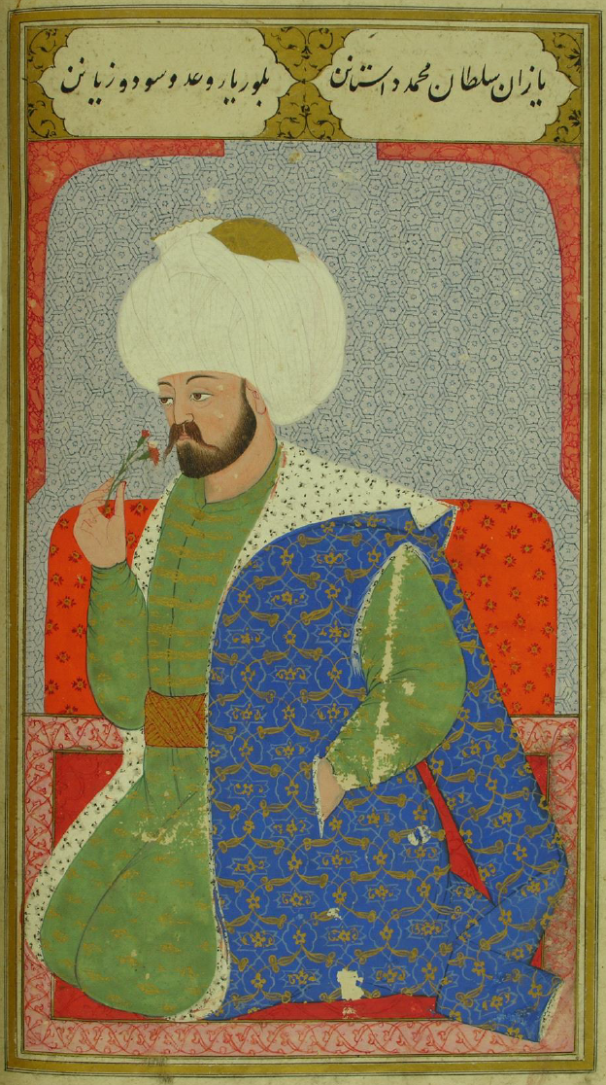
Figure 1: Mehmed I, Mehmed Çelebi, Hüdavendigâr, Kıyafetü’l-İnsaniyye fî Şemâili’l-Osmâniyye (TSMK, H. 1563)

In each portrait, the emperor seems disinterested, the expressionless and iconic faces showing the influence of the Byzantine iconography. On the other hand, following the Eastern figural representation style, they are also often depicted with flowers or handkerchiefs in their hands; Murād III, the commissioner of the work, is given the privilege of being the only figure depicted holding a book. The hands and faces of the emperors are the only planes without ornamentation across all twelve paintings. During my initial encounter with the portraits, I was especially drawn to the delicacy of the emperors’ hands, and the contrast between their intimate grip on the objects and the frozen expressions on their faces. The hands, with long fingers, radiate a sensuality that counters the emperors’ otherwise folded and enwrapped bodies.
To elaborate on the flatness observed in these illustrations: The compositional elements of the background, the belt, the seat, the cushion, and the kaftan cut up the image into several distinct visual planes. The visual effect can especially be observed in Mehmed Çelebi’s portrait, shown in Figure 1. The bright blue plane of the kaftan is embroidered with an elaborate arabesque pattern, with minimal breaks along the folds, and appears completely flat around Mehmed Çelebi’s hand placed in the pocket; the floral pattern appears as if floating on the surface of the kaftan’s fabric. A similar observation can be made about the large floral pattern on Murad-ı Hüdavendigâr’s kaftan, shown in Figure 2: these large flowers seem to have a life on their own, giving the portrait a hallucinatory quality. Despite the overarching visual continuity that unifies the album, minor differences start to emerge where patterns meet their implementation. These can be observed in the details of the girih patterns in the background and the illustrator’s depiction of the kaftans across different portraits. No two motifs are ever exactly the same, evokes Marks’s idea of art that “invites different kinds of thinking: between representation and performativity, empathy and abstraction, materialism and abstraction.”

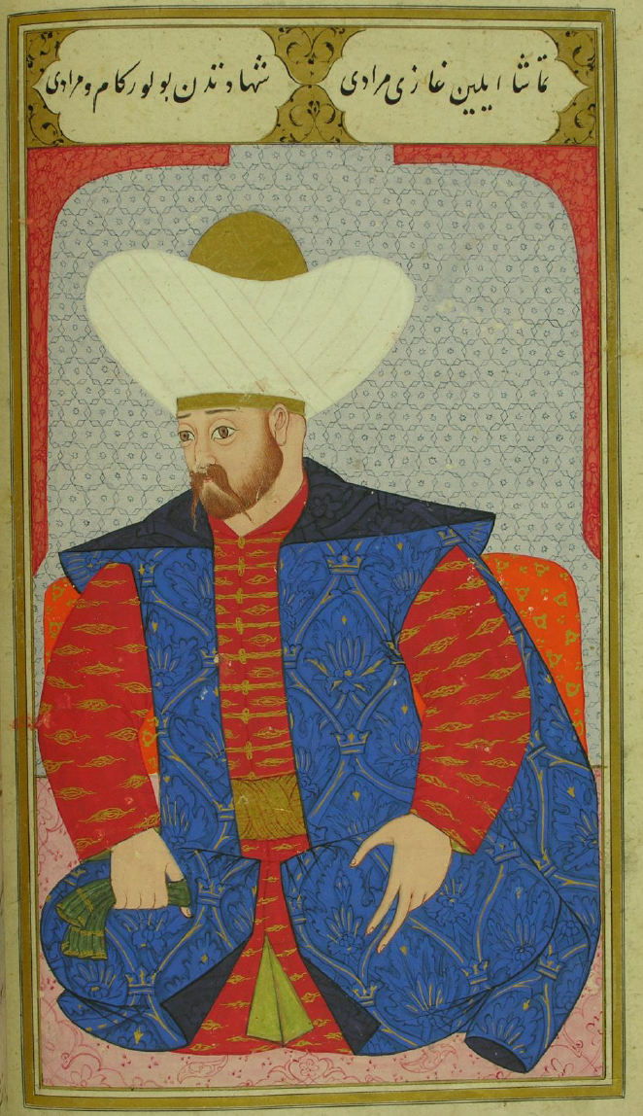
Figure 2: Murad I, Murad-ı Hüdavendigâr, Kıyafetü’l-İnsaniyye fî Şemâili’l-Osmâniyye (TSMK, H. 1563)
To further extend the iconographic significance of the ornamental layer in Şemailname, I want to turn to Grabar’s definition of implied geometry as an occulted geometry of regular motifs supporting writing, vegetation, animals or even personages that have almost lost their calligraphic, vegetal or animal senses, and is used primarily in the ornamentation of the kaftans of the emperors. These presents a geometry whose point is rarely itself, but it is rather a convenient means with which to hang a narrative, ornamental or other. Grabar’s implied geometry operates within a low-level iconography specificity: The figural is occulted without giving up its potential to be decoded in the observer’s mind. Grabar, in an attempt to expand his theory around the ornamental, suggests that contemporary painting can be understood as “a series of attempts to use abstract and simplified features to evoke representations of animals, and perhaps even of humans.” “The genius of the artist lies in the success of his occlusion of meaning.” Grabar’s argument suggest that ornament is an intermediary art and its geometric constructions can be used to evoke an expression of the essence of things. He presents examples of ornamentation in Islamic architecture contrived with the intention to induce in their beholder’s mind the idea that the structures are covered with textiles; geometry was manipulated to create the textile esthetic.
A closer analysis of each ornamental layer in the portraits shows that each layer embodies a different level of iconographic specificity. The upper part of the background is always decorated with a variant of the aniconic girih-style patterns, while the lower part, the seat, always has vegetal or floral patterns with a higher level of iconographic specificity. This emulates an almost algorithmic approach which draws the gaze to the miniscule differences between small units, releasing the energy contained in each bit and evoking a sense of intimacy through this shift in scale. The intimacy of the gaze restored through the ornamental layer, I argue, is similar to that of which is felt in DeepDream’s information-based images: we are drawn into these images through a shift in our perception: the overwhelming of our perception through the overabundance of information is followed by an intimacy afforded by our entry into the image via a small point.
To conclude my examination of Şemailname, I argue that despite the persistent visual elements that signal the continuity of the dynasty, the ornamental layer of the work invites a more contemplative gaze, emphasizing the individual, in terms both of the subjectivity of the beholder’s gaze and of each emperor’s persona. The abstract line is the element that essentially liberates the sensuality and the vital force of the Figural, by drawing the eye into the tenderness of these images. Thus, these lines have an inner life, and they incite a contemplative gaze which not only beautifies the beholder’s inner world, but also promotes pleasure, knowledge and wisdom.

DeepDream and the Emergence of “Not-So-Figural” Forms
Here I turn my thoughts from Şemailname to DeepDream, and argue that the software’s ability to adjust the level of iconographic specificity in its reinterpretation of images evokes a similar embodied response by enlarging our capacity for perception. Designed to shed light on the black-box nature of deep neural networks, DeepDream moves beyond simply being an algorithm that generates patterns, as chance and randomness are an integral part of the images it produces.

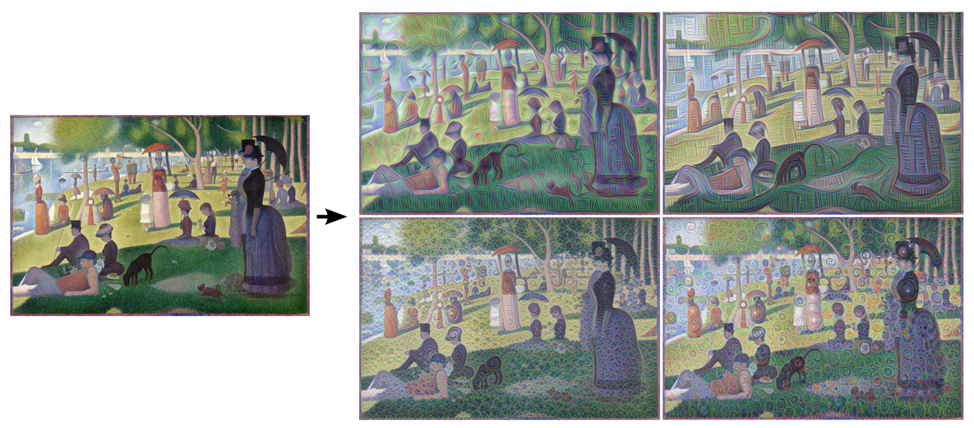
Figure 3: Georges Seurat’s “Un dimanche après-midi à l'Île de la Grande Jatte” (1884) and the processed images by Matthew McNaughton, Software Engineer.

The processing of the Georges Seurat painting shown in Figure 3 demonstrates four different versions populated by ornament-like patterns calculated through the engagement of lower levels of the network. Here, I propose that these patterns constitute abstract lines, and the visual result is sheer movement and energy, disturbing the absoluteness of the figuration. The literal twists and coils that emerge in Seurat’s painting when it is algorithmically convolved direct the gaze away from the stability of the figures and into the realm of movement. The lines produced and superimposed by the software are independent of figuration, and their function is not to reiterate figuration; therefore, each line appears as a second undoing of European figurative art. Here, I compare these patterns to the girih-style ornamental patterns seen in the miniatures of Şemailname: the minute differences and the different types of energy released when the beholder’s gaze is held for extended periods of time, taking notice of the slight differences between each iteration and extending them into infinity. Moreover, the ornamental layers observed in both visual cultures can be understood as the surfacing of visual layers comprised of many iterations of a single motivic idea, extending into infinity. Thus, the surfaces populated with abstract lines make these images about one’s own perception, engaging the inner senses and allowing one to contemplate what the eye is drawn to. In this way these DeepDream images are pre-iconographic, and similar to the geometric girih patters of Islamic ornamentation, present in details of the background and the arch in Şemailname.
On the other hand, feedback loops that engage the higher layers of the network have the ability to “identify more sophisticated features in images, [and] complex features or even whole objects tend to emerge.” These images yield more sophisticated results, as they are information based objects that are truly original, equipped with the ability to release the energy of smaller forms. The cloud reading example analysis below, provided in the original Google AI Blog post, presents how this can challenge figuration.

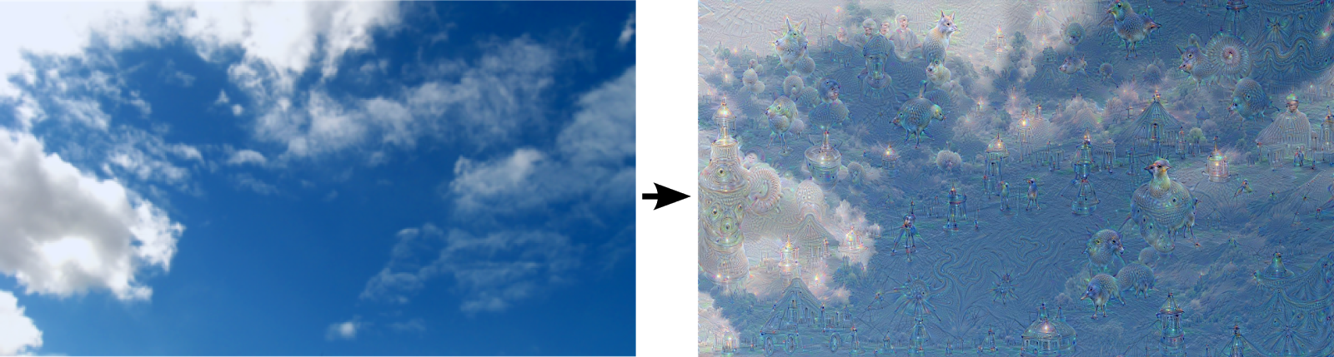
Figure 4: Original image processed by the higher network layer. Image credit: Google AI Blog.

Mordvintsev et al. describe this process as “a feedback loop: if a cloud looks a little bit like a bird, the network will make it look more like a bird. This in turn will make the network recognize the bird even more strongly on the next pass and so forth, until a highly detailed bird appears, seemingly out of nowhere.” The cloud-watching example shown in Figure 4 demonstrates how the low-level iconographic specificity observed especially in the images produced through the engagement of higher network levels liberates the abstract line. DeepDream produces icons without bodies: these emergent hollow figures move into the domain of the ornamental. Marks argues, referring to Deleuze’s concept of the Figural that destroys figurative images from within, releasing abstract yet embodied energies, that “we should attribute the power of the Figural to the non-figurative, or not-quite-figurative patterns that invaded Western painting from the East.” These disembodied figures, or rather “not-so-figural” forms seem to have an almost spontaneous existence; their actuality is felt to be in a constant state of flux. Marks observes that “Whether the carpets themselves are Figural probably lies in whether a person comes to them with a figurative mindset in the first place.” Thinking back on Ibn al-Haytham’s concept of visually complicated forms, the thin forms produced by DeepDream demand a contemplating gaze from their beholder, thereby engaging the inner senses. The visualizations of DeepDream, often reminiscent of digital psychedelia, populate the source images with layers of small forms to materialize in an absurd yet organic manner, and although most of these forms might not be considered exciting as an individual unit, through their abundance, they gain the ability to unleash the imaginative power of their beholder’s gaze.

Contemplative Spectatorship and Searching for Immanent Infinity
To return, in conclusion, to the role of contemplative spectatorship in Islamic art, I characterize the abstract lines of the ornamental layer as engaging the inward gaze. In the portraits of Şemailname, the patterns operate in tandem with the overarching principles of identity and difference: reinforcing the theme of the legitimacy and continuity of the Ottoman dynasty, while also allowing their beholder to notice the tenderness of the individual personality of each emperor. Taking as a point of departure Ibn al-Haytham's psychology of perception that requires internal faculties to make sense of visual experience, I extended the theory of the inner sense and the role of contemplative spectatorship to the images produced by Google’s DeepDream, and attempted to search for an immanent infinity within the ornament-like patterns and hollow figures that populate these images.

Bibliography
Belting, Hans. “The Double Perspective: Arab Mathematics and Renaissance Art,” Third Text
24:5 (2010): 521-527.

Deleuze, Gilles. Cinema 2: The Time Image, trans. Hugh Tomlinson and Robert Galeta. London:
The Athlone Press, 1989.

Grabar, Oleg. The Formation of Islamic Art. New Heaven, CT: Yale University Press, 1973.

Grabar, Oleg. The Mediation of Ornament. Princeton, NJ: Princeton University Press, 1995.

Grabar, Oleg. “When Is a Bird a Bird?” Proceedings of the American Philosophical Society
Vol. 153, No. 3 (2009): 247-253.

Marks, Laura U. Enfoldment and Infinity: An Islamic Genealogy of New Media Art. Cambridge,
MA: MIT Press, 2010.

Marks, Laura U. “Thinking Like a Carpet: Embodied Perception and Individuation in
Algorithmic Art.” In Entautomatisierung [Deautomatization], ed. Annette Brauerhoch et
al: 39-57. Paderborn, Germany: Wilhelm Fink, 2013.

Marks, Laura U. “The Taming of the Haptic Space, From Málaga to Valencia to Florence,”
Muqarnas: An Annual on the Visual Cultures of the Islamic World 32 (2015): 253-275.

Mordvintsev, Alexander, Christopher Olah and Mike Tyka. “DeepDream – a Code Example of
Visualizing Neural Networks.” Google Research Blog:
“https://ai.googleblog.com/2015/07/deepdream-code-example-for-visualizing.html,” 01-07-2015.

Mordvintsev, Alexander, Christopher Olah and Mike Tyka. “Inceptionism: Going Deeper into
Neural Networks.” Google Research Blog:
“https://ai.googleblog.com/2015/06/inceptionism-going-deeper-into-neural.html,” 17-06-
2015.

Necipoğlu, Gülru. “The Scrutinizing Gaze in the Aesthetics of Islamic Visual Culture: Sight,
Insight and Desire.” Muqarnas: An Annual on the Visual Cultures of the Islamic World
32 (2015): 23-61.

Necipoğlu, Gülru. “Early Modern Floral: The Agency of Ornament in Ottoman and Safavid
Visual Cultures” In Histories of Ornamental: from Global to Local, eds. Gülru Necipoğlu
and Alina Payne: 132-155. Princeton, NJ: Princeton University Press, 2016.

Peçe, Zaliha. “Nakkaş Osman ve Levni'ye Ait Padişah Portrelerinin Kompozisyon ve Teknik
Açıdan Karşılaştırılması.” PhD diss., Fatih Sultan Mehmet Vakıf Üniversitesi, 2015.

Spratt, Emily L. “Dream Formulations and Deep Neural Networks: Humanistic Themes in the
Iconology of the Machine-Learned Image,” in Critical Approaches to Digital Art History,
ed. by Angela Dressen and Lia Markey, in kunsttexte.de, Nr. 4, 2017 (15 pages), www.kunsttexte.de.

Gülru Necipoğlu, “The Scrutinizing Gaze in the Aesthetics of Islamic Visual Culture: Sight, Insight and Desire,” Muqarnas: An Annual on the Visual Cultures of the Islamic World 32 (2015): 40.
Alexander Mordvintsev, Christopher Olah and Mike Tyka, “DeepDream – a code example visualizing Neural Networks.” Google Research Blog: “https://ai.googleblog.com/2015/07/deepdream-code-example-for-visualizing.html,” 01-07-2015.
Google Research Blog, “DeepDream – a code example visualizing Neural Networks.”
Alexander Mordvintsev, Christopher Olah and Mike Tyka, “Inceptionism: Going Deeper into Neural Networks.” Google Research Blog: “https://ai.googleblog.com/2015/06/inceptionism-going-deeper-into-neural.html,” 17-06-2015.
The images produced by DeepDream belong to the category of “operational images,” at term coined by Harun Farocki and explored in his texts and installations since 2000. These images are essentially produced for computer vison specialists to understand the inner workings of the deep convolutional neural network based image classification pipeline.
Gülru Necipoğlu asserts this principle in her work, and here I am specifically referring to the instance in the Introduction of Histories of Ornament: from Global to Local.
Laura U. Marks, “Thinking Like a Carpet,” in Entautomatisierung [Deautomatization], ed. Annette Brauerhoch et al (Paderborn, Germany: Wilhelm Fink, 2013), 50.
Laura U. Marks, Enfoldment and Infinity (Cambridge, MA: MIT Press, 2010), 156.
Marks, Enfoldment and Infinity, 306.
Marks, Enfoldment and Infinity, 19. Instead, Marks advocates artworks that generate a sense of immanent infinity.
Google Research Blog, “DeepDream – a code example visualizing Neural Networks.”
Hans Belting, “The Double Perspective: Arab Mathematics and Renaissance Art,” Third Text 24:5 (2010): 523.
Marks, “Thinking Like a Carpet,” 40.
Laura U. Marks, “The Taming of the Haptic Space,” Muqarnas: An Annual on the Visual Cultures of the Islamic World 32 (2015): 253.
While this paper primarily addresses Belting’s essay “The Double Perspective: Arab Mathematics and Renaissance Art,” his book Florence and Baghdad: Renaissance Art and Arab Science (Cambridge: Belknap Press of Harvard University Press, 2011) develops these concepts further.
Belting, “The Double Perspective,” 524.
Belting, “The Double Perspective,” 524.
Belting, “The Double Perspective,” 525.
Belting, “The Double Perspective,” 534.
Belting, “The Double Perspective,” 527.
Gülru Necipoğlu, “Early Modern Floral,” In Histories of Ornamental: from Global to Local, eds. Gülru Necipoğlu and Alina Payne (Princeton, NJ: Princeton University Press, 2016), 132.
Necipoğlu, “The Scrutinizing Gaze in the Aesthetics of Islamic Visual Culture,” 30.
Necipoğlu, “The Scrutinizing Gaze in the Aesthetics of Islamic Visual Culture,” 29.
Necipoğlu, “The Scrutinizing Gaze in the Aesthetics of Islamic Visual Culture,” 30.
Necipoğlu, “The Scrutinizing Gaze in the Aesthetics of Islamic Visual Culture,” 30.
Necipoğlu, “The Scrutinizing Gaze in the Aesthetics of Islamic Visual Culture,” 40.
Necipoğlu, “The Scrutinizing Gaze in the Aesthetics of Islamic Visual Culture,” 53.
Grabar, The Mediation of Ornament (Princeton, NJ: Princeton University Press, 1995), 87.
Grabar, The Formation of Islamic Art (New Heaven, CT: Yale University Press, 1973), 232.
Grabar, The Mediation of Ornament, 120.
Zaliha Peçe, “Nakkaş Osman ve Levni'ye Ait Padişah Portrelerinin Kompozisyon ve Teknik Açıdan Karşılaştırılması” (PhD diss., Fatih Sultan Mehmet Vakıf Üniversitesi, 2015), 24.
Peçe, “Nakkaş Osman ve Levni'ye Ait Padişah Portrelerinin Kompozisyon ve Teknik Açıdan Karşılaştırılması,” 106.
Marks, “Thinking Like a Carpet,” 40.
Grabar, The Mediation of Ornament, 132.
Oleg Grabar, “When Is a Bird a Bird?” Proceedings of the American Philosophical Society Vol. 153, No. 3 (2009): 251.
Grabar, “When Is a Bird a Bird?” 253.
Grabar, The Mediation of Ornament, 141.
Necipoğlu, “The Scrutinizing Gaze in the Aesthetics of Islamic Visual Culture,” 49.
Marks, “Thinking Like a Carpet,” 52.
Here I want to mention that Laura Marks pointed out to me Seurat’s technique is already undoing European figurative painting, with images intended to compose themselves in the viewer’s eyes.
Google Research Blog, “Inceptionism: Going Deeper into Neural Networks.”
Google Research Blog, “Inceptionism: Going Deeper into Neural Networks.”
Marks, “Thinking Like a Carpet,” 54.
Marks, “Thinking Like a Carpet,” 54.

